Critical to Quality (CTQ) Tree
A CTQ Tree is a tool used to translate the voice of the customer (VOC) or critical need into measurable requirements.
- Identify the VOC or critical need.
It is the overall goal at a very high level.
- Identify the quality drivers.
These are the characteristics that are used to further define the critical need.
The quality drivers become more granular.
- Identify the performance requirements that are metrics used to evaluate the outcome.
The requirements are very specific and further define the critical need.
Example 1: Good Coffee
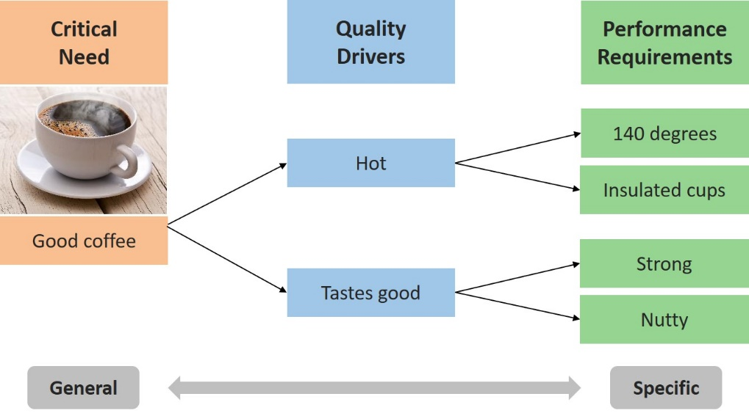
Example 2: Good Care
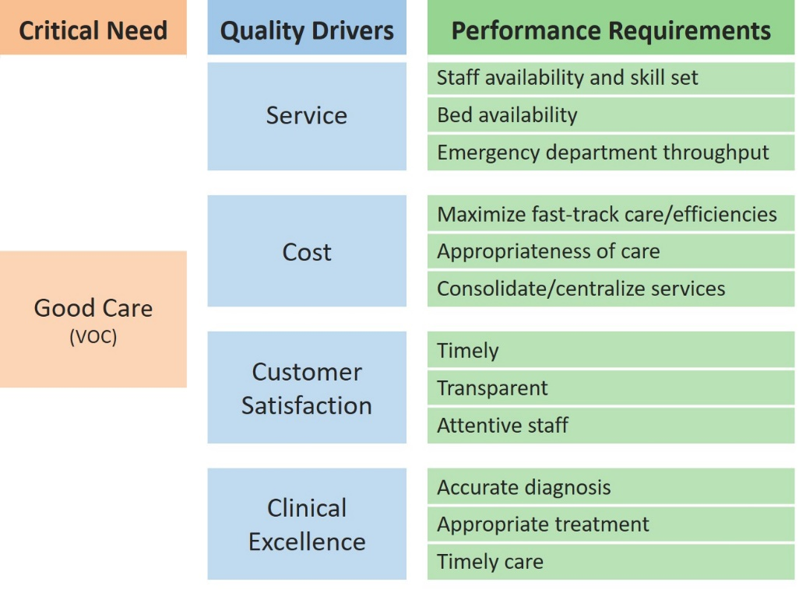
Quality Drivers
Critical Need
Performance Requirements
This material was prepared by Health Services Advisory Group (HSAG) Hospital Quality Improvement Contractor (HQIC), under contract with the Centers for Medicare & Medicaid Services (CMS), an agency of the U.S. Department of Health and Human Services. The contents presented do not necessarily reflect CMS policy. Publication No. XS-HQIC-QI-06072021-01

