[Nursing Home Name] COVID-19 Vaccination Recognition Program

COVID-19 Vaccination Goal
[Nursing Home Name] will vaccinate 75% of staff members and 90% of residents by [Enter Date].
Key Program Elements:
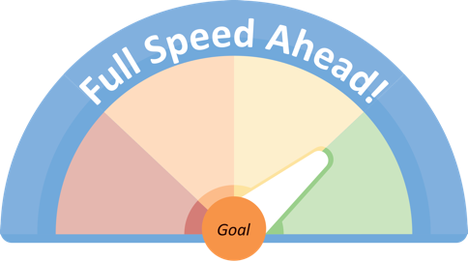
- Create COVID-19 vaccine program team to carry out tasks, including director and assistant director of nursing, and unit managers.
- Enter weekly vaccine data into the National Healthcare Safety Network (NHSN) for compliance, to prioritize outreach, and to monitor goal.

COVID-19 Vaccine Program Activity Recommendations
 | Activity Recommendation | Evidence-Based Rationale¹ | HSAG Resources
 | Hold 1:1 conversations with staff using motivational interviewing (MI). Schedule follow-up conversations. Send thank you notes. | Empathy as key to interacting with those who may be vaccine hesitant or skeptical, including through such techniques as MI. | MI Webinar Training:  https://bit.ly/MIwebinarHSAG
 | Recruit staff members who are willing to talk and answer questions from colleagues. Train using MI. | Research shows that people look to their peers for cues about how to behave in a wide range of areas. | Peer Ambassadors:  https://bit.ly/ImprovingVaccineAcceptance
 | Have medical director hold meetings with staff to answer any questions about the vaccine. | Consider tailored messaging down to the individual level using MI. | MI Resources:  https://bit.ly/ImprovingVaccineAcceptance
 | Place posters promoting COVID-19 vaccine appointments around building for staff members and residents to see. | Develop different messages for those who need information on how to do so and those who are hesitant but open to learning more. | Other Communication Strategies:  https://bit.ly/ImprovingVaccineAcceptance
 | Post a public vision board so staff members can share why they got the vaccine or what activities they are enjoying after vaccination. | Making vaccine uptake visible will encourage a social norming of vaccine acceptance. People look to their peers for cues about how to behave. | Vision Board/Goal Poster: www.hsag.com/covid-19/vaccine-resources
 | Publicly track facility’s vaccine goal in a public place for everyone to see. | Making vaccine uptake visible will encourage a social norming of vaccine acceptance. Transparency is key. | Vision Board/Goal Poster: www.hsag.com/covid-19/vaccine-resources
 | Share new evidence with staff about the safety of the vaccine during huddles or in newsletters. | Transparency is key, particularly as new data and evidence become available. | Vaccine Evidence: https://bit.ly/ImprovingVaccineAcceptance
 | Hold community meetings to identify messengers and other potential support for vaccine uptake. | Community organizations are close to their audiences; can tailor information effectively; and have trusted leaders who can be effective spokespersons. | Other Communication Strategies:  https://bit.ly/ImprovingVaccineAcceptance
 | Other: | Other:
Reference
- National Academies of Sciences, Engineering, and Medicine 2021. Strategies for Building Confidence in the COVID-19 Vaccines. Washington, DC: The National Academies Press. https://doi.org/10.17226/26068.

