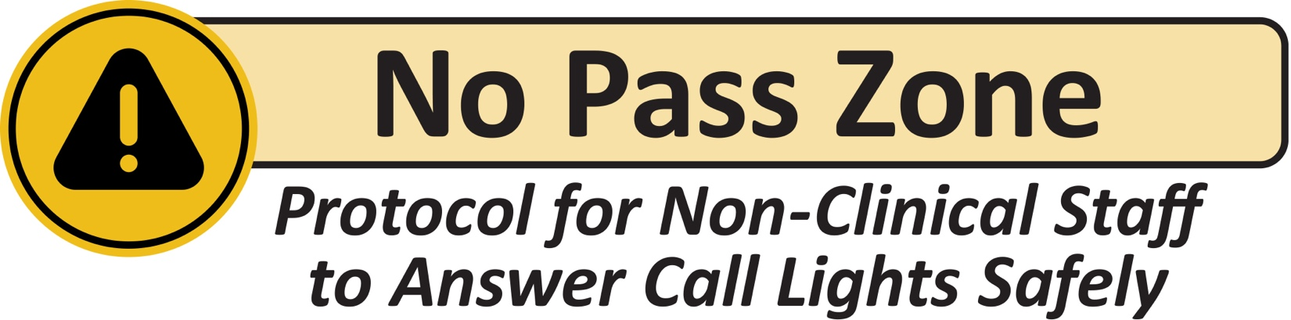
When answering a call light:
Gel in (hand hygiene) and knock before entering. |  | Greet the resident and introduce yourself by name. |  | Say, “I see your call light is on. How can I help you?”
✅ YES, YOU CAN  Non-clinical staff CAN:  - Provide comfort items (blankets,  tissues, towels).  - Adjust TV, radio, blinds, or lighting.  - Place personal items (phone, charger, table, trash can) within reach.  - Move an existing water pitcher that already contains water closer to the resident and/or pour the water if asked.  - If the request is outside your role:  - Say, “Let me find someone to  help you.”  - Do not turn off the call light until the request is addressed. |  |  | 🚫 NO, YOU CAN’T  Non-clinical staff must NOT:  - Explain diagnoses, treatments, or  care plans.  - Manage intravenous lines (IVs), oxygen, or medical equipment.  - Physically move, lift, or reposition  a resident.  - Raise, lower, or adjust beds or  side rails.  - Open or close doors to rooms with isolation precautions or restricted access.  - Give food, drink, or medications.  - Remove meal trays or water pitchers.
If the request involves safety, health, or mobility,
notify the nursing staff immediately.
Before leaving:
Ask, “Is there anything else I can assist you with?” | Make sure the resident’s call light  is in reach. |  | Turn off the call light  if the request was addressed. |  | Gel out  (hand hygiene).

