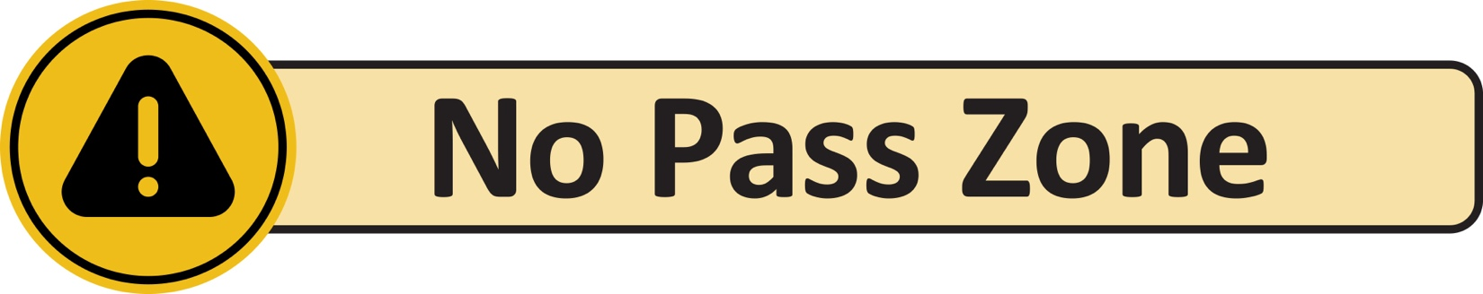
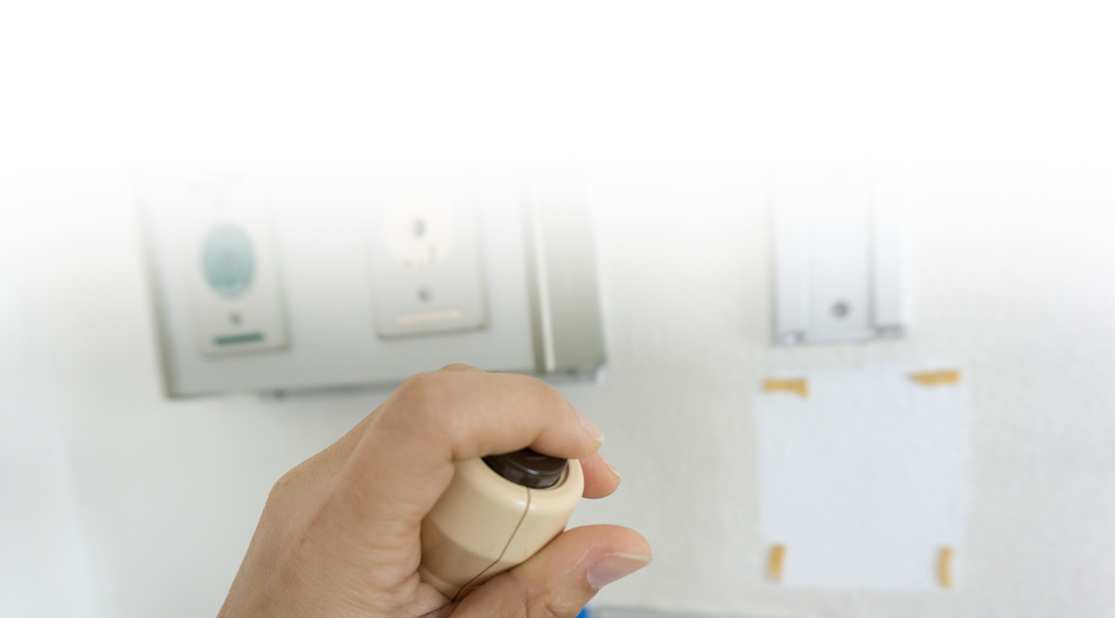
ALL staff, ALL call lights, ALL the time.
Our team works together to keep you safe,
comfortable, and cared for.

What This Means for You:
We Work as a Team | Help is On the Way | No Request is Too Small
Every staff member is committed to answering your call light. | The nearest staff member will respond,  no matter his or her job. | If someone cannot help right away, he or she will get the right person.
Your care is our priority.

