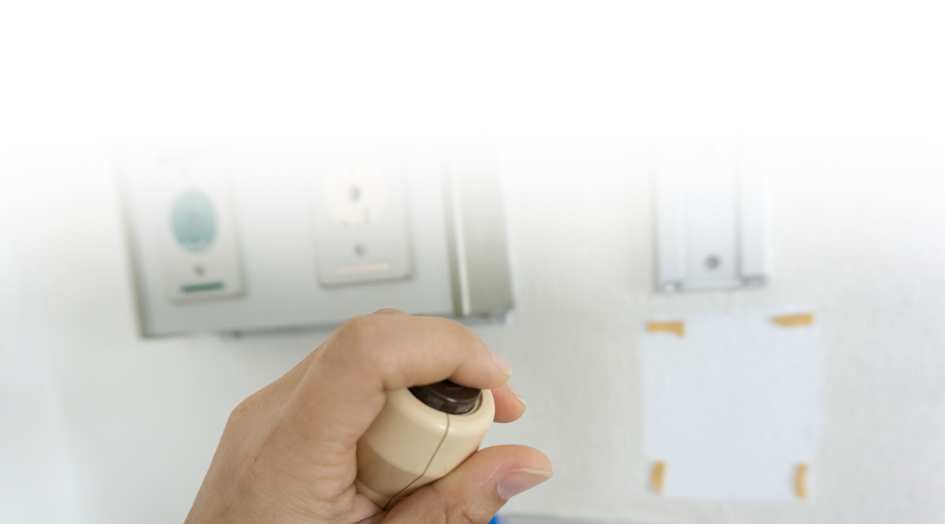
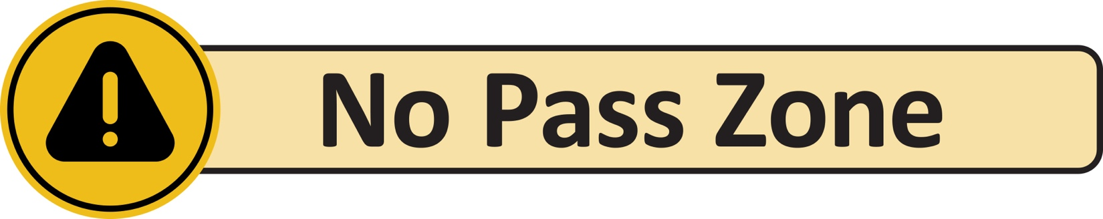
ALL staff, ALL call lights, ALL the time.
Regardless of your role or department,
if you see a resident call light on,
stop and answer it.
Why This Matters?
Improves  resident safety | Reduces falls  and injuries | Improves customer service | Strengthens teamwork

What This Means for Staff:
We Work as a Team | Nearest Staff Respond | We Help or Hand Off
Every staff member is responsible for  responding to call lights. | The nearest staff member answers the call light, no matter his or her job. | Help the resident  or get the right  person to help.
Teamwork keeps residents safe.

