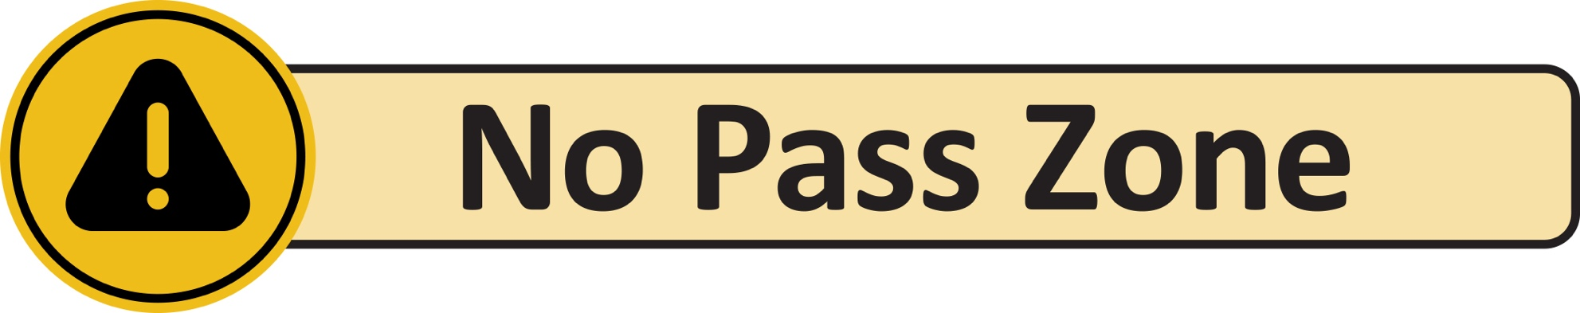
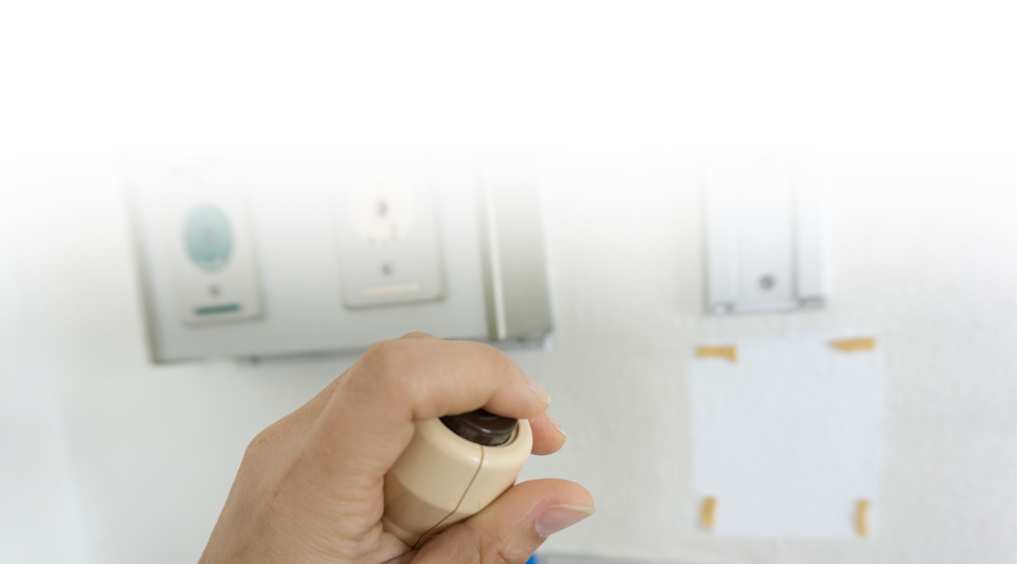
ALL staff, ALL call lights,
ALL the time.
Regardless of your role or department,
if you see a resident call light on,
stop and answer it.
Why This Matters?
Improves resident safety | Reduces  falls and injuries | Improves customer service | Strengthens teamwork

What This Means for Staff:
We Work as  a Team | Nearest Staff Respond | We Help or  Hand Off
Every staff member is responsible for  responding to  call lights. | The nearest staff member answers  the call light, no matter his or her job. | Help the resident or get the right person to help.
Teamwork keeps residents safe.

